EENG 385 - Electronic Devices and Circuits

Full Bridge Rectifier

Lab Handout

# Outcome and Objectives

The outcome of this lab is to build a full-bridge rectifier to convert an AC input to the DC voltage. Through this process you will achieve the following learning objectives:

* Analyze and design a circuit containing one or more diodes.
* Use laboratory test and measurement equipment to analyze electronic circuits.

# Full-bridge Rectifier Theory:

A rectifier is an electrical device that converts an AC signal into a DC signal. A full-bridge rectifier is a rectifier that uses the arrangements of four diodes shown in Figure 1 along with the 100uF capacitor C1. The input to this rectifier is the 17V AC signal on the left side of Figure 1. The DC output of the rectifier is the voltage difference Vrec+ to Vrec-. The load is modeled as the 1k resistor R1.

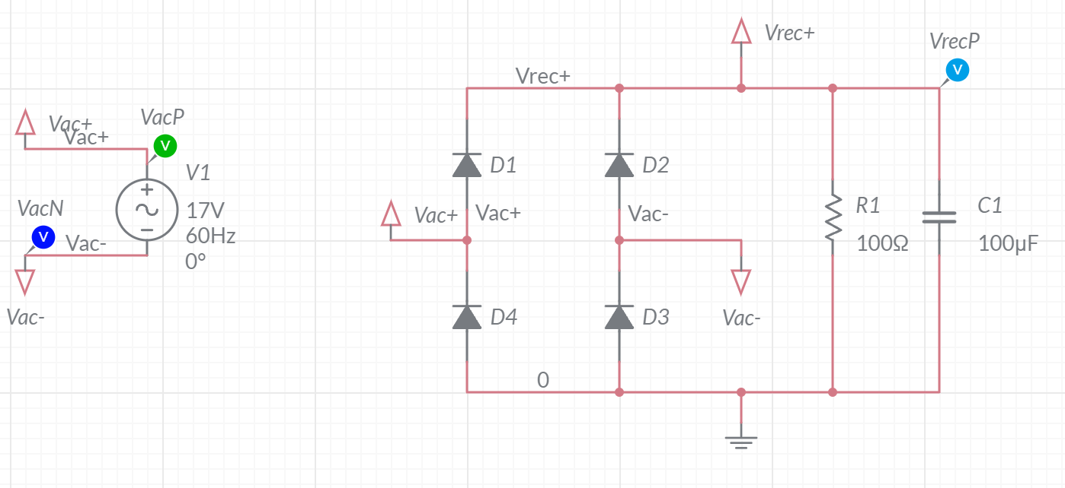

Figure : The full bridge rectifier converts the 17V AC input into DC output.

Let’s start our journey by examine the function of the four diodes in Figure 1 by applying the waveform shown in Figure 2 as the AC input. For this thought experiment, remove the resistor R1 and capacitor C1 from the circuit. The green waveform in Figure 2 is Vac+ and the blue waveform is Vac-. Assume a diode drops 0.7V when forward biased.

1. If Vac- is less than -0.7V with respect to GND, what diode is conducting?

**Diode D3 is conducting.**

1. If Vac+ is 0.7V higher than Vrec+, what diode is conducting?

**Diode D1 is conducting.**

1. When Vac- is below -0.7V and Vac+ is above 0.7V, what pair of diodes are forward biased (conducting) and what pair are reverse biased (off).

**Diodes D1 and D3 are forward biased. Diodes D2 and D4 are reversed biased.**

1. When Vac- is less than -0.7V, the Vac- terminal of the AC source is fixed at -0.7V. Thus, during this time the amplitude of Vac+ is referenced to -0.7V. What is the peak amplitude of Vrec+ during this time?**Since Vrec+ is 1 diode drop below Vac+ and Vac- is 1 diode drop below ground, then Vrec+ should be 17V – 2*0.7V = 15.6V.**
2. If Vac+ is less than -0.7V with respect to GND, what diode is conducting?

**Diode D4 is conducting.**

1. If Vac- is 0.7V higher than Vrec+, what diode is conducting?

**Diode D2 is conducting.**

1. When Vac+ is below -0.7V and Vac- is above 0.7V, what pair of diodes are forward biased (conducting) and what pair are reverse biased (off).

**Diodes D2 and D4 are forward biased. Diodes D1 and D3 are reversed biased.**

1. When Vac+ is less than -0.7V, the Vac+ terminal of the AC source is fixed at -0.7V. Thus, during this time the amplitude of Vac- is referenced to -0.7V. What is the peak amplitude of Vrec+ during this time?

**Since Vrec+ is 1 diode drop below Vac- and Vac+ is 1 diode drop below ground, then Vrec+ should be 17V – 2*0.7V = 15.6V.**

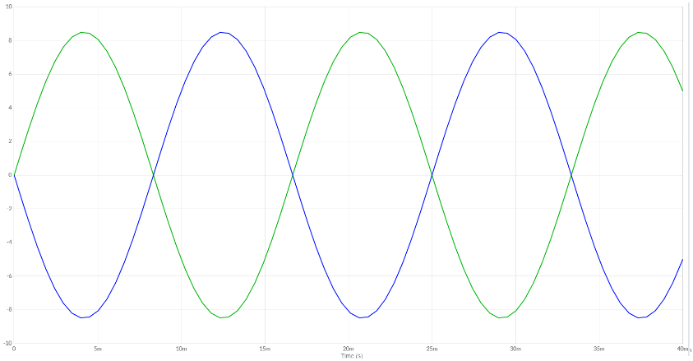

Figure : The Vac+, Vac- input to the full-bridge rectifier.

Now that you have a better understanding of the role of the 4 diodes in Figure 1, let’s explore the role of the capacitor and resistor.

The addition of the capacitor (but no resistor) to the rectifier acts to hold the highest value of Vrec+ on the positive plate of the capacitor. The addition of the load resistor causes the stored charge on the capacitor to bleed off through the resistor when the input waveform is less than Vrec+.

The capacitor C1 in Figure 1 is called the “filter capacitor” because, along with the load resistor, forms a low pass filter with time constant R1*C1. If the time constant of this low pass filter is large compared to the period of the 60Hz ac input, the capacitor voltage will look like a DC voltage with low amplitude 60Hz ripples between the peaks of the AC input. We will explore these ripples in the following section.

# Full-bridge Rectifier Simulation:

Let’s look at the detailed behavior of the full-bridge by simulating the circuit in Figure 1. Do this by logging into your Multisim Live account. You can find the parts for the Multisim schematic using the information in the following table.

|  |  |  |
| --- | --- | --- |
| Component | Tool | Name |
| AC Voltage | Sources | AC Voltage |
| Connector | Schematic connectors | Connector |
| Diode | Diodes | Diode |
| Capacitor | Passive | Capacitor |
| Resistor | Passive | Resistor |

Significant settings:

* R1 = 100Ω
* C1 = 100uF.
* Set simulation to run for 40ms. To set this, double click on a blank region of the schematic revealing the Document properties pull-out. This is where you will set the End time field to “40m” – the seconds units are provided.

After completing these steps, run the simulation. Your Grapher output should look like Figure 3.

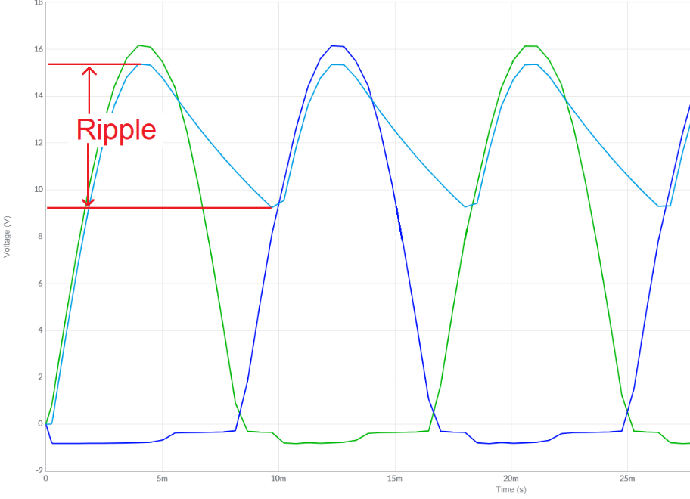

Figure : Ripple voltage is the difference between the highest and lowest voltage on Vrec+. The green and dark blue traces are the Vac+/Vac- input respectively, the light blue trace is the Vrec+ output.

One attribute of a power supply is the ripple voltage which is the peak-to-peak variation of the output. In Figure 3, the ripple voltage is 15.4V – 9.3V = 6.1V. The duration of this drop in voltage starts at the peak of Vac voltage and ends when Vrec+ starts increasing. In Figure 3, the duration of the voltage drop is 18ms – 12.3ms = 5.7ms.

The ripple voltage depends on the resistor and capacitor in Figure 1 because once the Vac voltage starts dropping off, the charging diodes become reverse biased, leaving the stored charge on the filter capacitor C1 to supply the output voltage. Since this capacitor voltage is in parallel with the load resistor R1, the capacitor discharges. This is an RC decay with the familiar equation, V0e-t/R1*C1

Let’s take a moment to measure the ripple voltage with different loads and compare it against a theoretical RC decay model in Table 1. To do this, simulate the full-bridge rectifier for the load resistors shown in the “Load Resistor” column in Table 1.

* Use the Grapher output to measure the ripple voltage (as shown in Figure 3). Put this value in the “Vsim_ripple“ column. Round to 3 significant figures.
* Multiply the load resistor times the filter capacitor and put this value in the “RC” column.
* Calculated the power dissipated through the load resistor using the V2/R equation. Do this by assuming that the average voltage is 15.6V – (Vsim_ripple/2) and R is the load resistor. Put this value in the Power column using the units of Watts. Round to 2 significant figures.

Table : The ripple voltage depends on the load resistances.

|  |  |  |  |  |
| --- | --- | --- | --- | --- |
| Load Resistor | Vsim_ripple | RC (ms) | Power (W) | Vact_ripple |
| 33 | **10.8V** | **3.3ms** | **(15.6-5.4)2/33 = 3.2W** | **Do Not Measure** |
| 100 | **6.20V** | **10ms** | **(15.6-3.1)2/100 = 1.6W** | **Measure**  **6.0V** |
| 330 | 2.80V | **33ms** | **(15.6-1.4)2/330 = 0.61W** | **Measure**  **2.8V** |
| 1,000 | **1.00V** | **100ms** | (15.6-0.5)2/1000 = 0.23W | **Measure**  **1.0V** |
| 3,300 | **0.400V** | **330ms** | **(15.6-0.2)2/3300 = 0.072W** | **Measure**  **0.38V** |

# Full-bridge Rectifier Implementation

Build the full bridge rectifier using the transformers in the lab. To do this you will need:

* Extension cord or
* 120V to 24V transformer
* Wire to connect transformer to
* Breadboard
* 4 1N4001 diodes
* Oscilloscope probe and DMM probes

## The KS21239L4 Transformer

Details on the KS21239L4 transformer are hard to come by (non-existent), but we can determine all the relevant details of the transformer using educated guesses and making measurements with your test and measurement equipment.  **You will start by making measurements with the transformer unplugged and with all stray wires removed from the screw terminals!** You can get a screwdriver from the tool cabinet in Brown 304 to remove all wires connected to the screw terminals.

Before you proceed, grab a pair of digital multimeter (DMM) cables, one red and one black. Connect the black cable to the COM jack on the BK Precisions DMM. Connect the red cable to the VΩ jack. Now, pick up and inspect the KS21239L4 transformer. The physical interface consists of a 3-prong 120VAC electrical connection and 4-screw terminal labeled 1, 2, 3, 4/GRD. I would bet that the GND prong of the 120VAC connector is connected to the screw terminal labeled “4/GRD”. Test this hypothesis by setting the BK Precisions DMM in the resistance mode (press the Ω button) and measuring the resistance between the GND prong and the “4/GRD” screw terminal.

1. What is the resistance between the GND prong and the “4/GRD” screw terminal? Are these two electrically connected?

**Yes, the GND prong and 4/GRD screw terminal connected.**

Now that we have that out of the way, let’s determine the configuration of windings in the transformer. My guess is that the transformer output is center tapped; meaning that the secondary winding is divided into two evenly split sections as shown in Figure 4.

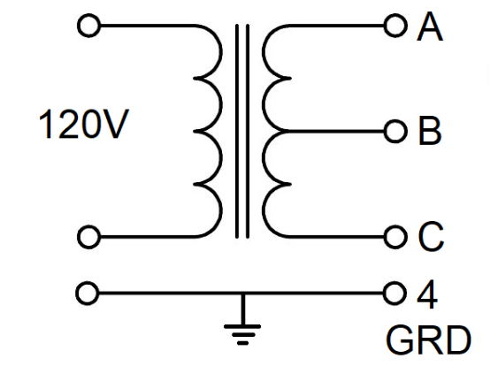

Figure : An educated guess at the internal organization of the xyz transformer.

In the following, we will assume that all the wire used in the secondary winding has the same resistance per unit length. If this is the case, then:

* The resistance between A and B will equal the resistance between B and C.
* The resistance between A and B will be half the resistance between A and C.

Use the DMM to probe the screw-terminals 1, 2 and 3. Note, the resistance between A/B and B/C may not be exactly equal, use an average value in your answer below.

1. What is the resistance between the A and B terminals?

**The resistance between the A and B terminals is about 3.3Ω.**

1. What is the resistance between the A and C terminals?

**The resistance between the A and B terminals is 6.6Ω.**

1. What screw-terminals are associated with A, B and C in Figure 4? Hint, there are two possible answers, just provide one.

**A = 1 B=2 C=3 or A=3 B=2 C=1**

The final answer that we need, is what screw-terminals we should use as the input to our transformer? To do this, you will need to plug in the transformer while having access to the screw terminals. I found that an extension cord works the bet and surge suppressor can make due.

The case of the transformer has printed text that described the voltage and current ratings of the primary and secondary.

1. What is the voltage for the primary winding and secondary winding?

**PRI: 120V**

**SEC: 24V**

The voltage specifications for the transformer are root mean squared (RMS), whereas and measurements that you will make on the oscilloscope are peak-to-peak. The relationship between the two is:

RMS voltage * sqrt(2) = Peak-to-peak voltage

Before proceeding, put the DMM into AC voltage measurement mode by pressing the **AC V** button. Now, plug in the transformer and use the DMM to measure the voltages of the following screw terminals.

1. What is the RMS voltage between terminals A and B in Figure 4? Convert this RMS voltage to peak-to-peak.

**The RMS voltage between terminals A and B is 13.3V. This RMS voltage corresponds to a peak-to-peak voltage of 13.3*sqrt(2) = 18.8V**

1. What is the RMS voltage between terminals A and C in Figure 4? Convert this RMS voltage to peak-to-peak.

**The RMS voltage between terminals A and B is 26.6V. This RMS voltage corresponds to a peak-to-peak voltage of 26.6*sqrt(2) = 37.6V**

Now attach a pair of wires to a pair of screw-terminals whose peak-to-peak voltage is close to 17V, the voltage that we used in the simulations of the previous section. These two wires will provide Vac+ and Vac- to your circuit.

## The 1N4001 diode

Unlike the transformer, there are plenty of details available on the 1N4001 diode. We will want to know a couple of these for our analysis.

* Go to digikey.com
* Search for 1N4001FSCT-ND
* Download the PDF Datasheet

Use the information in the datasheet to answer the following questions:

1. What is the Maximum Average Rectified Forward Current?

**The Maximum Average Rectified Forward Current is found from the MAXIMUM RATINGS table as 1.0 A**

1. What is the voltage drop across the diode (in our lab) when the current is 0.1A? Hint, use Figure 1.

**The voltage drop is a little less than 0.8V at 0.1A.**

1. What is the maximum repetitive reverse voltage that you can safely apply across the diode?

**The maximum repetitive reverse voltage is found from the MAXIMUM RATINGS table as 50V.**

1. What end of the diode is the white band placed? Hint, search the document for “Band”.

**The white band indicates the cathode of the diode.**

## The 100uF capacitor

You should use a capacitor that is rated for at least 35V in this experiment. I used a 50V to give myself a wide-margin. Go to the parts electrolytic capacitor drawer in the Brown 304 parts cabinet and get a 35V, 50V or 100V, 100uF capacitor. The voltage rating is printed on the sleeve of the capacitor – you should always double check this when removing a component from the parts

It is critically important that you install the electrolytic capacitor in correctly. If installed backwards, they will fail catastrophically and could cause eye-injury. Please get eye protection from the tool-cabinet in Brown 304 is you do not wear eyeglasses.

1. How is negative terminal of this capacitor indicated?

**The sleeve has an arrow with a minus sign in it that points to the negative lead.**

## Assembly

Assembly of the full-bridge rectifier is made more difficult by the thick leads on the 1N4001 diodes. These leads are hard to insert into the breadboard. Do yourself and grab a pair of needle-nose pliers from the tool cabinet in Brown 304. Hold most of the lead of the diode in the pliers with about ¼” sticking out. Use the pliers to firmly push the lead into the breadboard.

Use the schematic in Figure 1 as a guide to arranging your diodes. Double-check the polarity of your diodes using your DMM in the diode checking mode (press the button with the diode symbol). The positive end of the diode (anode) should be on the GND side of the circuit (right in Figure 5) and the forward voltage drop should be around 0.5V.

You should come up with something that looks similar to Figure 5.

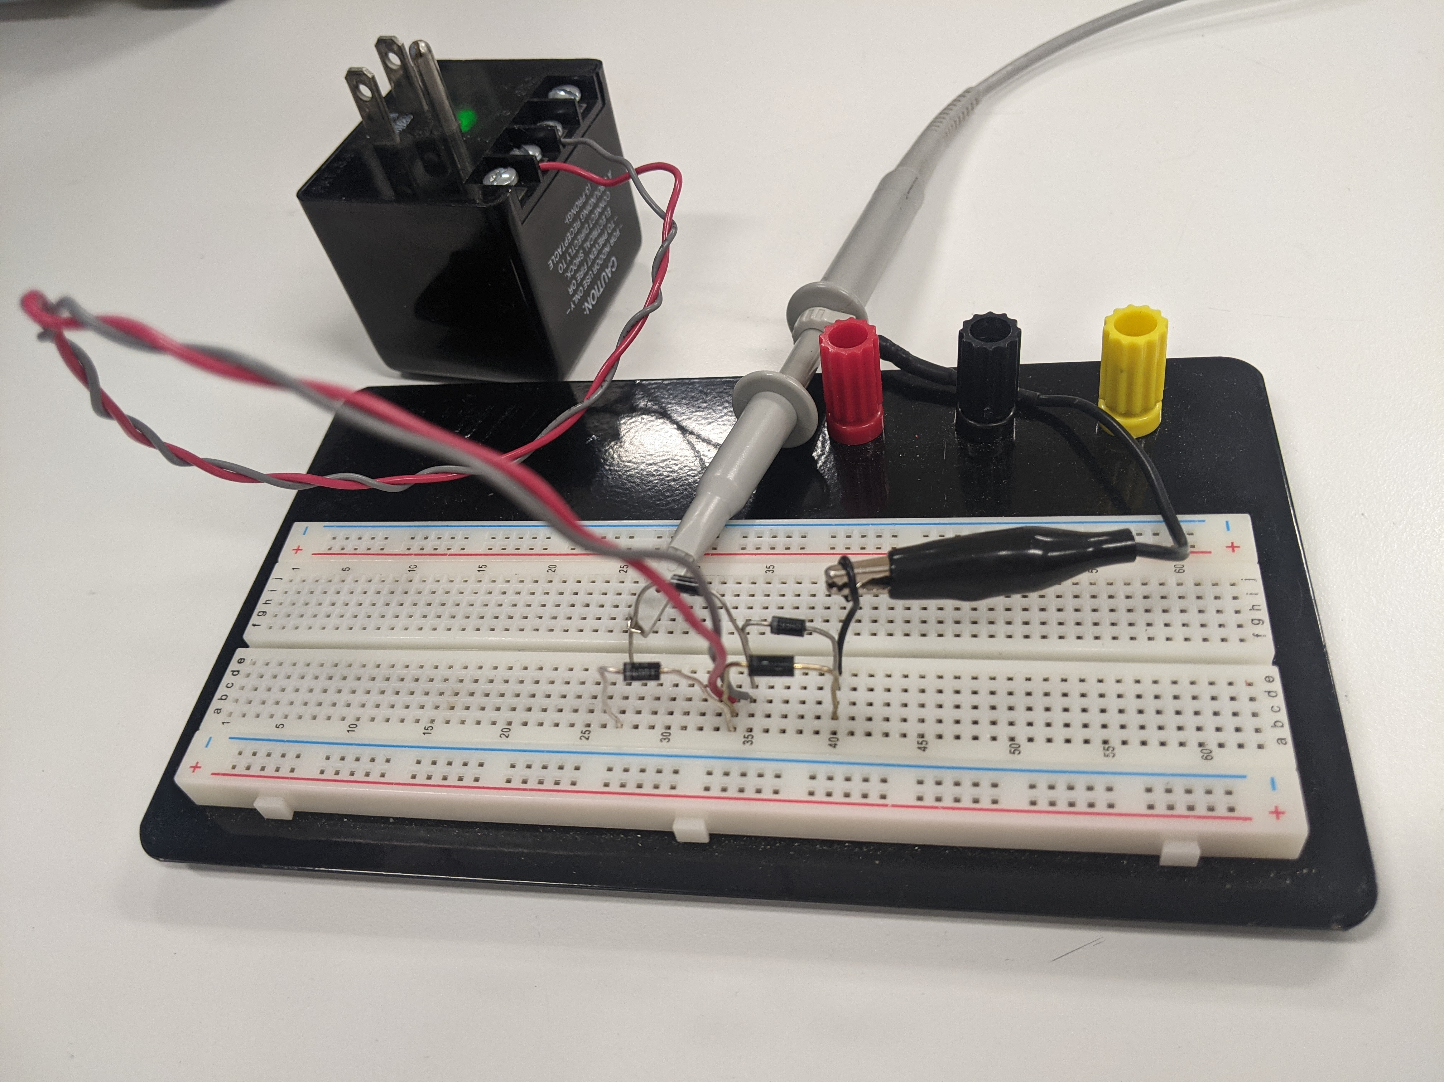

Figure : The diodes and AC input of the rectifier are assembled and ready to test. The GND clip forms the GND node in your circuit.

Let’s check what you have assembled so far. To do this configure your oscilloscope as follows:

|  |  |
| --- | --- |
| Horizontal (scale) | 5ms |
| Ch1 probe | Vrec+ terminal |
| Ch1 (scale) | 5V/div |
| Ch1 (coupling) | DC |
| Trigger source | 1 |
| Trigger slope | ↑ |
| Trigger level | 10V |

Verify that your oscilloscope output looks very similar to Figure 6.

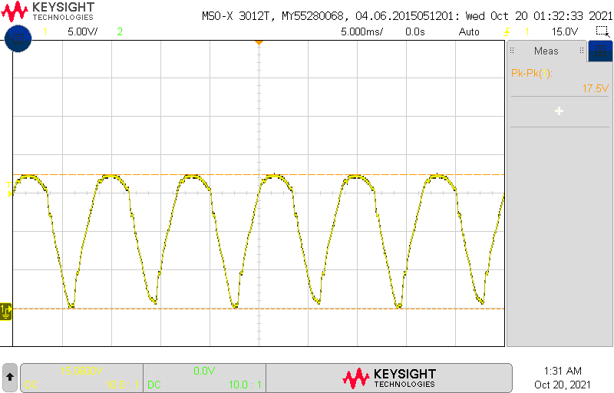

Figure : The Vrec+ output of the full-bridge rectifier with no filter capacitor and no load resistor.

Unplug your transformer before proceeding.

Add the 100uF filter capacitor across the Vrec+ and GND terminals. Make sure the negative polarity arrow points to GND. Keep your oscilloscope connected to Vrec+.

Apply power and verify that your oscilloscope output looks very similar to Figure 7.

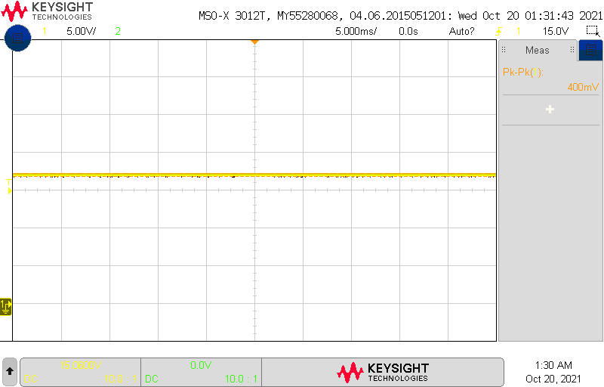

Figure : The Vrec+ output of the full-bridge rectifier with a filter capacitor and no load resistor.

Unplug your transformer before proceeding.

Add the blue 3-Watt 100Ω load resistor in parallel with the filter capacitor - across the Vrec+ and GND terminals. Keep your oscilloscope connected to Vrec+.

Apply power and verify that your oscilloscope output looks similar to Figure 8.

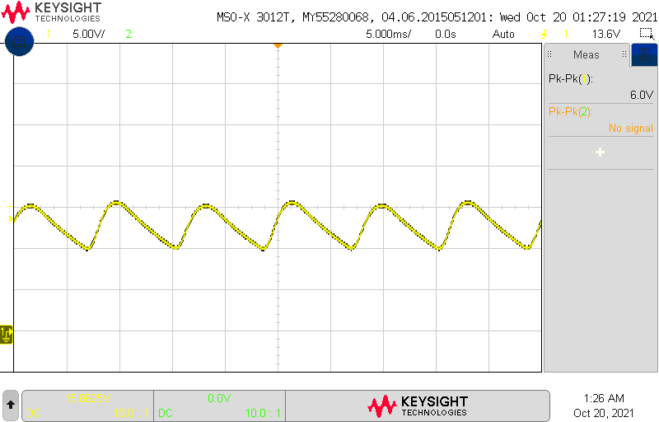

Figure : The Vrec+ output of the full-bridge rectifier with a filter capacitor and 100Ω load resistor.

Measure the ripple of the Vrec+ output for the 100Ω resistor. Record this in Table 1.

Measure the ripple voltage using the following resistors. Make sure to record the magnitude of the ripple voltage in Table 1. While all these resistors are sized to handle the power dissipation you calculated in Table 1, the resistors may get hot to the touch. If you operate the full-bridge rectifier for a long time with a resistor in place, be cautious when touching it.

* A 1Watt 330 ohm resistor
* A ¼ Watt 1k resistor (normal sized resistor from blue cabinet in Brown 304)
* A ¼ Watt 3.3k resistor (normal sized resistor from blue cabinet in Brown 304)

# Turn in

Make a record of your response to numbered items below and turn them in a single copy as your team’s solution on Canvas using the instructions posted there. Include the names of both team members at the top of your solutions. Use complete English sentences to introduce what each of the following listed items (below) is and how it was derived.

**Full Bridge Rectifier Theory**

Steps 1 – 8

**Full Bridge Rectifier Simulation**

Fully completed Table 1

**Full Bridge Rectifier** **Implementation**

**The KS21239L4 Transformer** Steps 1-7

**The 1N4001 diode** Steps 1-4

**Assembly** Complete Table 1

**Sign-off, successful implementation** Record this in the rubric